
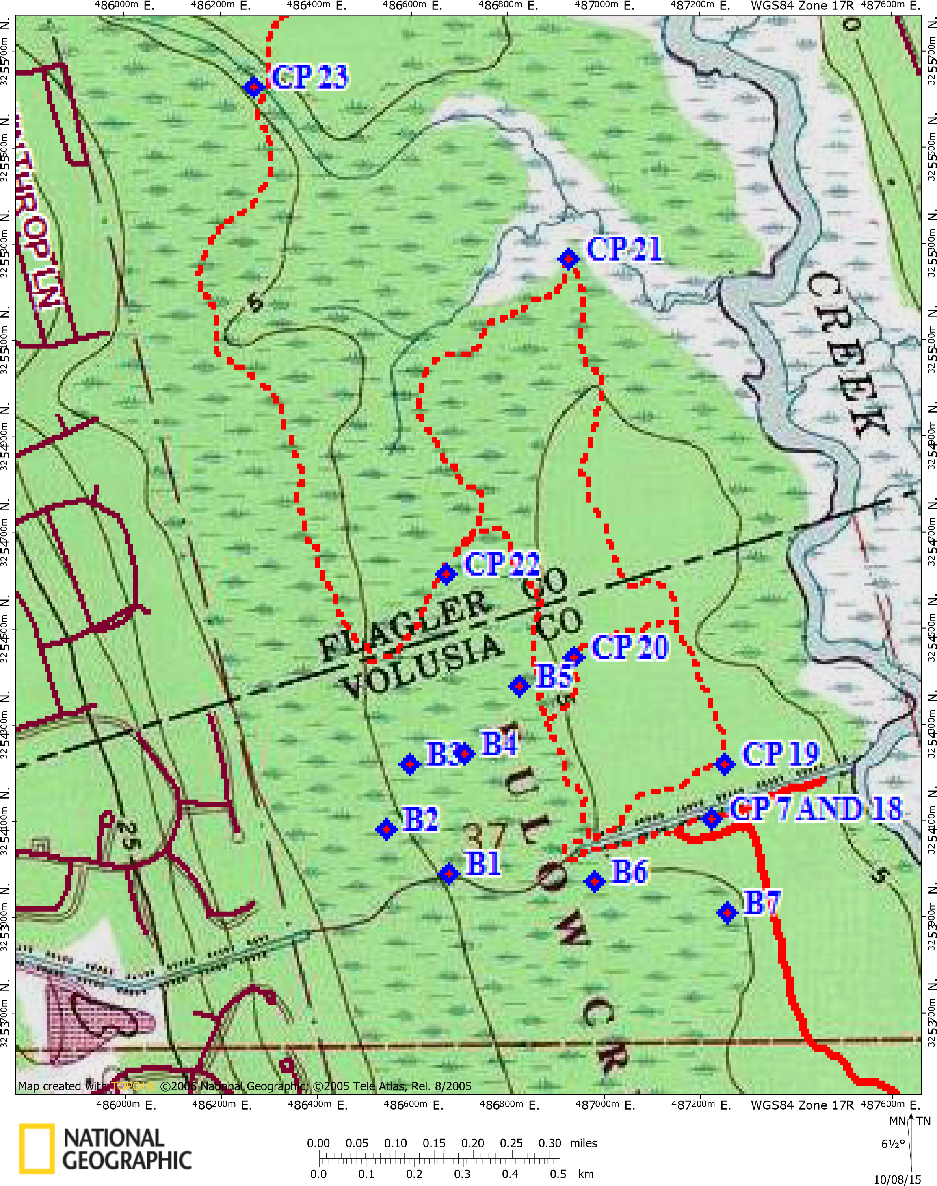
FOOT 1 - the old blue trail
On foot get the following CPs.
CP 1 (B1) – Small tree along creek
CP 2 (B2) – Palm
CP 3 (B3) – Hickory tree
CP 4 (B4) – Tall Oak trunk
CP 5 (B5) – Large Oak
CP 6 (B6) – High in tree south of ponds
CP 7 (B7) – Tree near marsh
Return to your boats and continue on. Don’t forget to exchange your punch cards.

